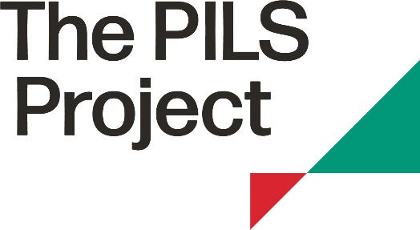

Training Request Form

The PILS Project can arrange training sessions on public interest issues for NGO and solicitor members. Depending on the topic/area of law, PILS staff or legal professionals from the Pro Bono Register will deliver the training.

1. Name of PILS member organisation:

2. Contact name and email address:

3. Details of the training requested (please give as much information as possible):

4. Who will attend the training? (e.g. service users, staff, board trustees)

5. Approximately how many people will attend the training?

6. How will the training benefit your organisation?

7. Any other relevant information:

(*Please note that the term ‘members’ refers to the human rights NGOs and solicitor firms who have joined our wider membership network. These organisations are not ‘members’ of PILS for company law purposes.)

