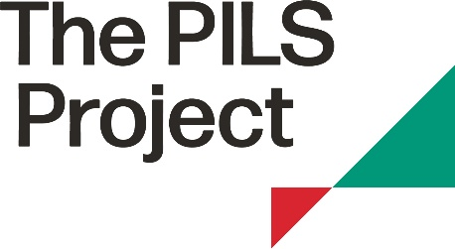

Application for a pro bono legal opinion

The PILS Project can source legal opinions from the Pro Bono Register for members on public interest issues.

Your details
Name of member organisation

Address

Contact name

E-mail address of contact

Telephone number

Date of application

1. Is this application urgent?
If yes, please give reasons, including details of any legal time limits, including those imposed by judges, statute or court rules that you are aware of.

2. Explain the issue and outline all developments to date. If you have identified an applicant in potential legal proceedings please confirm.

3. Explain how a legal opinion will further your work in this area (if known).

4. Please explain what you want the legal opinion to address?

Signed:……………………………………………

(*Please note that the term ‘members’ refers to the human rights NGOs and solicitor firms who have joined our wider membership network. These organisations are not ‘members’ of PILS for company law purposes.)

